**CP Club 365 Days Challenge**

**Programming language – C++**

**Problem Statement**

<https://www.codechef.com/problems/BIRDFARM>

Git :- <https://github.com/Vedantbharad2603/CP_club_365_Days>

**Your Code**:

// 0x112Day of 0x365Days challenge

// VEDANT BHARAD

// 6-2-2023

#include <iostream>

using namespace std;

int main() {

    // your code goes here

    int t;

    cin>>t;

    while(t--){

        int x,y,z;

        cin>>x>>y>>z;

        if(z % x == 0 && z % y != 0){

            cout<<"CHICKEN"<<endl;}

        else if(z % y == 0 && z % x != 0){

            cout<<"DUCK"<<endl;}

        else if(z % x != 0 && z % y != 0){

            cout<<"NONE"<<endl;}

        else{

            cout<<"ANY"<<endl;}

    }

    return 0;

}

**Output (Screen Shot)**:

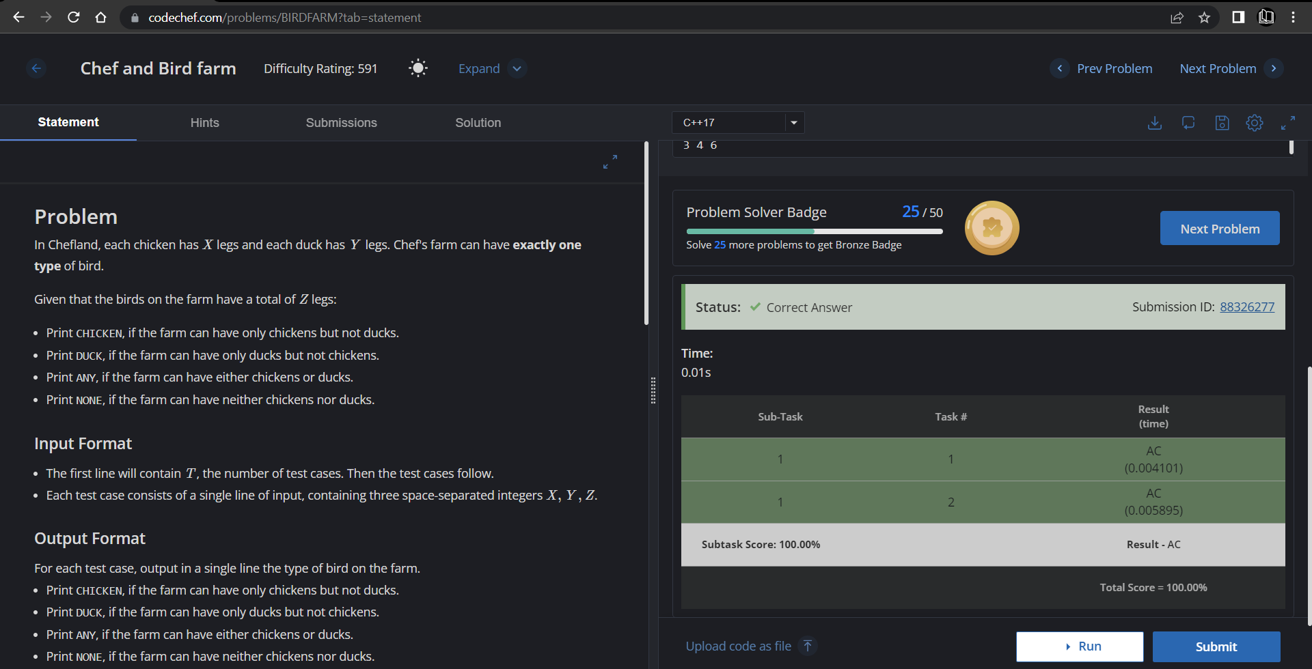

**Understanding about problem:**

* In this task I need to return CHICKEN,DUCK,NONE or ANY based no input
* If z % x == 0 && z % y != 0 then return CHICKEN,if z % y == 0 && z % x != 0 then return DUCK,if z % x != 0 && z % y != 0 then return NONE else ANY.

Note: If you can't understand the problem, feel free to contact us and we'll help you. Please don't copy and paste from anywhere.

ALL THE BEST

Team CP Club